

MEnu List


Please choose your meals from the menus below

When done, record your selections using the ‘Input Meal Choice’ button:

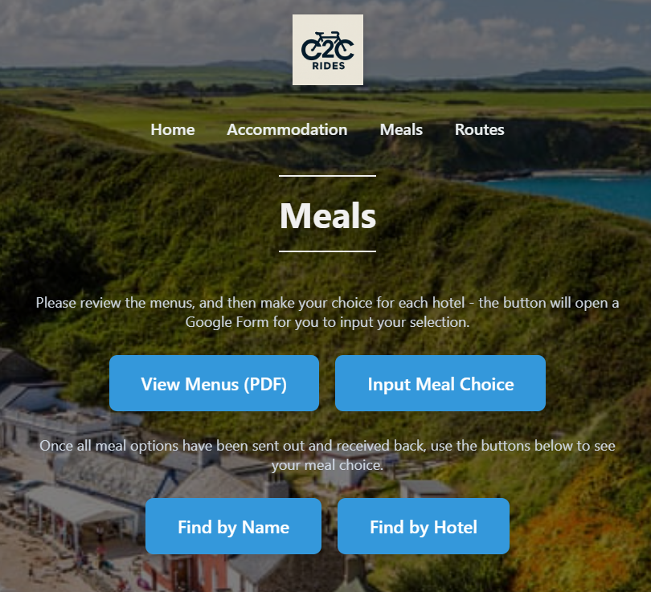

Hotel | Location
The Manor | Conwy
Lion Hotel | Criccieth
Nanhoran Arms | Nefyn
The Bull | Beaumaris

